PURCHASE TICKET FROM DRIVER
November 3, 2017
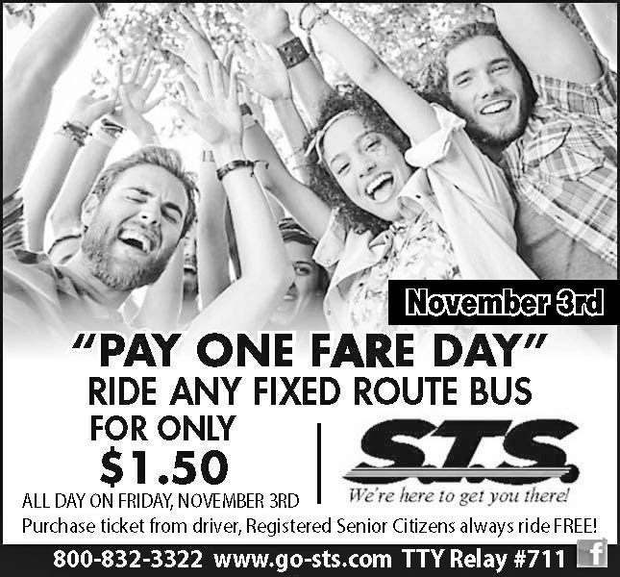

REGISTERED SENIOR CITIZENS ALWAYS RIDE FREE WITH THEIR BUS PASS!

